CONTROLLING POP UPS IN GEMS/MARS
When you are using GEMS/MARS for the first time, you may encounter pop ups. These are within the system and open when you are using certain areas of the system. The first time you encounter them, your computer system may ask you if you wish to “Allow Pop-Ups from this site”. Always allow the pop ups. You may be asked this question in different ways depending upon which browser you are using.
Many times, a message will pop up when you click on a place in GEMS/MARS that has a pop up. It may look something like this and on the right side you will notice a button that says OPTIONS. Click on this and it will give you different options for allowing or disallowing pop ups from this site.
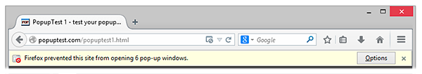

Each browser has their own way of handling pop ups. Ways to get help from Firefox, Internet Explorer, and Chrome are below.

Firefox: https://support.mozilla.org/en-US/kb/pop-blocker-settings-exceptions-troubleshooting
Click on this link and you will be taken to the pop up page within Firefox.
Internet Explorer: http://windows.microsoft.com/en-us/internet-explorer/ie-security-privacy-settings#ie=ie-11
Click on this link and you will be taken to the pop up page within Internet Explorer.
Chrome: https://support.google.com/chrome/answer/95472?hl=en
Click on this link and you will be taken to the pop up page within Chrome.

